**Benchmark Color Palette Search Tools**

1. Coolors, <https://coolors.co/palettes/trending>

Descriptions: Adobe’s Coolors has two main features : generating color palettes and exploring trending color palettes. In searching trending color palettes, a search bar pops up where basic colors can be searched. These basic colors are red, orange, brown, yellow, green, turquoise, blue, violet, pink and grey – a total of 10 basic colors. The searched color name will be added as a tag to the filters. The filters can be extended to more color names in the search query. The searched basic colors are mapped to a set of corresponding HEX colors for fetching corresponding color schemes. It suffices to have one color in this set of HEX colors included in the color scheme for the color scheme to display in the search results. The color scheme has the HEX color shown when hovering over a color patch in the color scheme. The resulting color schemes contain five color patches. These color schemes are made by coolors’ users. The color schemes can be viewed, saved or exported. Also, there exists the option to open the chosen palette in the Coolors color palette generator or copying the URL of the color scheme.

Evaluation: It is also possible to search color schemes by HEX code, but the possibility to search color palettes by HEX code is not made obvious in the search bar. There are no names for the color schemes being displayed.

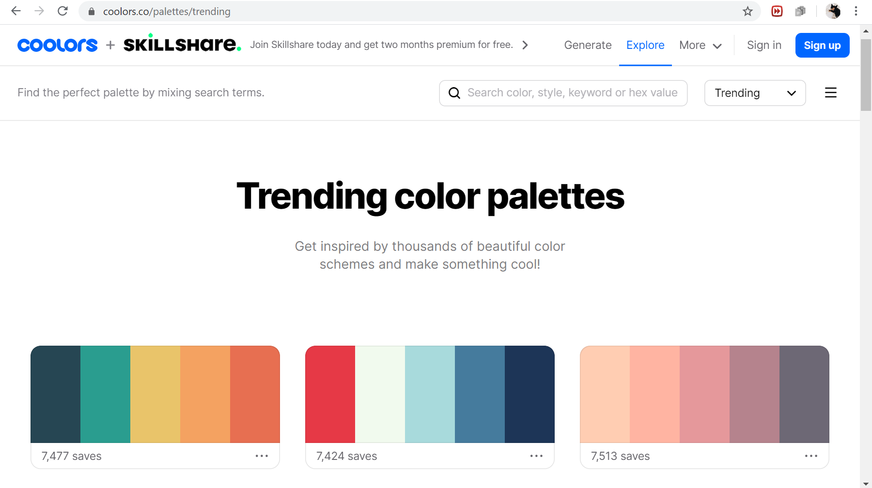

Figure 5: Coolors' Search Palette Webpage

1. Muzli – Designers’ Secret Source, <https://colors.muz.li/color/ccffcc>

Description: Searching for color names, such as “aliceblue”, “dark” or “antiquewhite”, or code (HEX code) in the search bar. Color name is converted to a HEX code. Color name is mapped to one HEX code only. For example, “brown” is “#A52A2A”. Color scheme of five color patches are given in the result. Color schemes are analogic, mono, triade, complementary, tetrade and random.

Evaluation: “Azure” as “#F0FFFF” is not how the general public sees the color “azure”. “Dark” is mapped to “#222222” only, but conceptually “dark” could be any color. In the search bar some color names are recommended in a list after typing the first few letters, however the colors are mostly neutrals, very light or dark only.

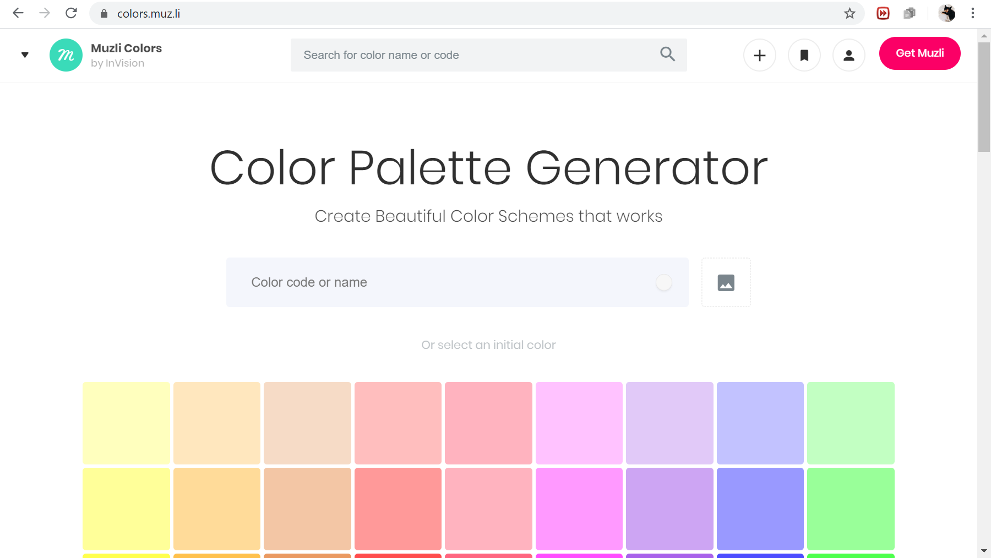

Figure 6: Muzli's Search Palette Webpage

1. ColourLovers, <https://www.colourlovers.com/palettes>

Description: The site has a color palette maker and search tool for exploring user-created color palettes. The searchbar for color palettes is more sophisticated: not only is it possible to search color palettes by keyboard (color names such as “wine”, “chocolate” and “teal”) and HEX code, it is also possible to search colors by RGB and HSV values. The HSV axes are displayed as colorbars next to the color picker window square. The search results are sortable by loves, name, date added, views and comments in descending or ascending order. Also, they can be sorted by hues. The search results can be filtered by publication date. The palettes in the search result are named, the user naming the palette is displayed too. In addition, each color palette comes with information about the number of comments, favorites, view and loves it had attained so far. There are five color swatches in a color scheme.

Evaluation: Although this site’s search functionality is the most sophisticated compared to other similar service providers, the mappings of “teal” to the color palettes containing the color is more fallacious than not. However, for “goldenrod” it is surprisingly accurate. In between are searches such as “crimson” with some false results among correct search results. Hence, it is not clear how the color names are mapped to the colors in the color palette. It is not clear why the color swatches vary in proportion in some color schemes and in others they are equally spaced.

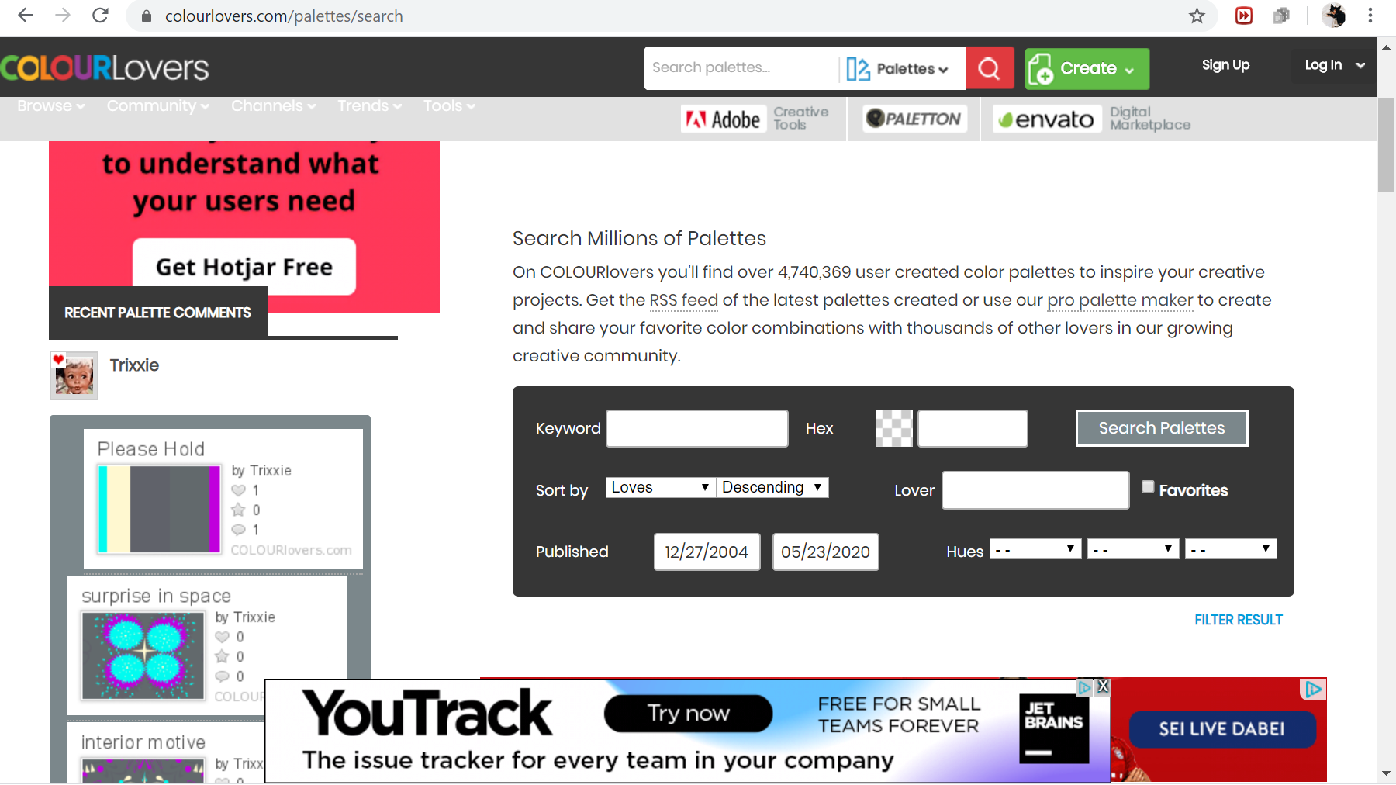Figure 7: ColourLovers' Search Palette Webpage

1. Color Hunt, <https://colorhunt.co/>

Description: The searchbar for color palettes suggest the color hues that are searchable which are red, orange, brown, yellow, green, turquoise, blue, purple, pink, grey, black and white – twelve hues in total. The color palettes are also searchable by contrast such as warm, cold, bright and dark. In addition, the color palettes can be searched by texture such as gold, neon, pastel, skin or by themes such as vintage, retro, wedding, Christmas, Halloween. Searching color palettes by climate such as sunset, summer, autumn, winter and spring is possible, too. The search results contain four color patches and information about the number of likes and the elapsed period since the color scheme has been published online. When hovering over the color swatches the HEX code of the color displays.

Evaluation: The color palettes are not named. While all color swatches’ proportional size remains equal across the color schemes, it is not clear why the colors occupy varying proportionate spaces within the color scheme.

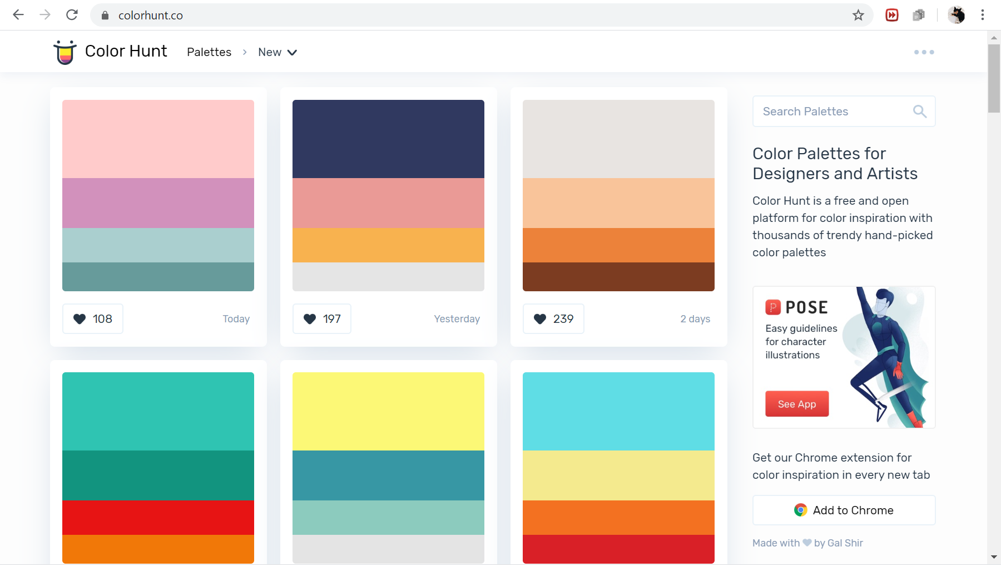Figure 8: Color Hunt's Search Palette Webpage

1. Design Seeds {for all who love color}, <https://www.design-seeds.com/>

Description: The search functionality for color palettes takes place by clicking on a color swatch in a 4x11 matrix of color swatches. The color swatches correspond to color names such as “blush”, “ice” or “metal” which are linked to a set of HEX codes.[1] If a color palette has one of this HEX code colors in them, it figures among the search results. The search results contain all the color palettes by name, date of publication, color patches and user name. There are always six color patches within a color scheme. The resulting color of a color palettes are displayed with their HEX code.

Evaluation: The color names of the searchable colors are not displayed on the searchable color chart. The image from which the color scheme is derived is viewable as well, but one color scheme might take up too much space because of the clean and informative exhibition of the color schemes.

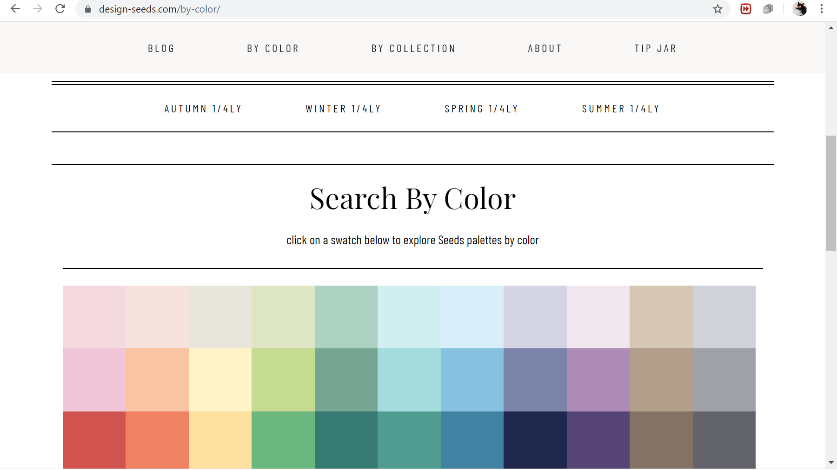Figure 9: Design Seeds' Search Palette Webpage

1. Color-hex, <https://www.color-hex.com/color-palettes/>

Description: The searchbar takes color names such as “chartreuse”, “babyblue” or “sunflower“, but also proper names such as “Arabica”, “Paris” or “Alps” and adjectives “frenzy”, “playful” or “bitter”. The search returns color schemes (called color palettes) containing five color patches and the name of the color scheme that is matched to the searched keyword. The name of the color scheme usually follows the pattern “left-most-color-name to right-most-color-name”, but descriptive names are also possible. The search results are clickable. On click, the color scheme is shown more prominently, with its title name, the username of the person who created the color scheme, and the color patches of the color scheme together with a list of its HEX code (on hovering as well) and RGB values. The color scheme is downloadable as PNG image. The HEX codes are clickable links that redirects to a page where the HEX code color and RGB values are showcased together with information of the colors values in many additional color spaces (HSL, HSV, CMYK called “process color”, XYZ, Yxy, Hunter Lab, CIE-Lab, web-safe HEX color code). Also the HEX color’s dominant color content (red, green or blue) is described. More information about the HEX color’s base numbers (binary, octal, decimal and hex) are provided in a table. The HEX color is recast to color schemes of shades and tints with eleven color patches each. Also, there are two bar charts that show the relative percentage of the RGB and CMYK channels for the HEX color. The HEX color is recast into color schemes of triadic (3), analogous (3), monochromatic (7) and complementary color (2) with the number of colors for the color scheme given in brackets. The HEX color can be previewed against a black and white background. There is information about the CSS embeddings of the HEX color and the HEX codes of related colors.

Evaluation: The information given in the redirected pages is exhaustive, but at the same time the search results could have more information on first view for example about the HEX codes of each color in the color scheme and the download functionality. A feature for an easier handling of the color space values such as the immediate copying onto the click board could help the user when working with color schemes. The color schemes in the search result are not sortable.

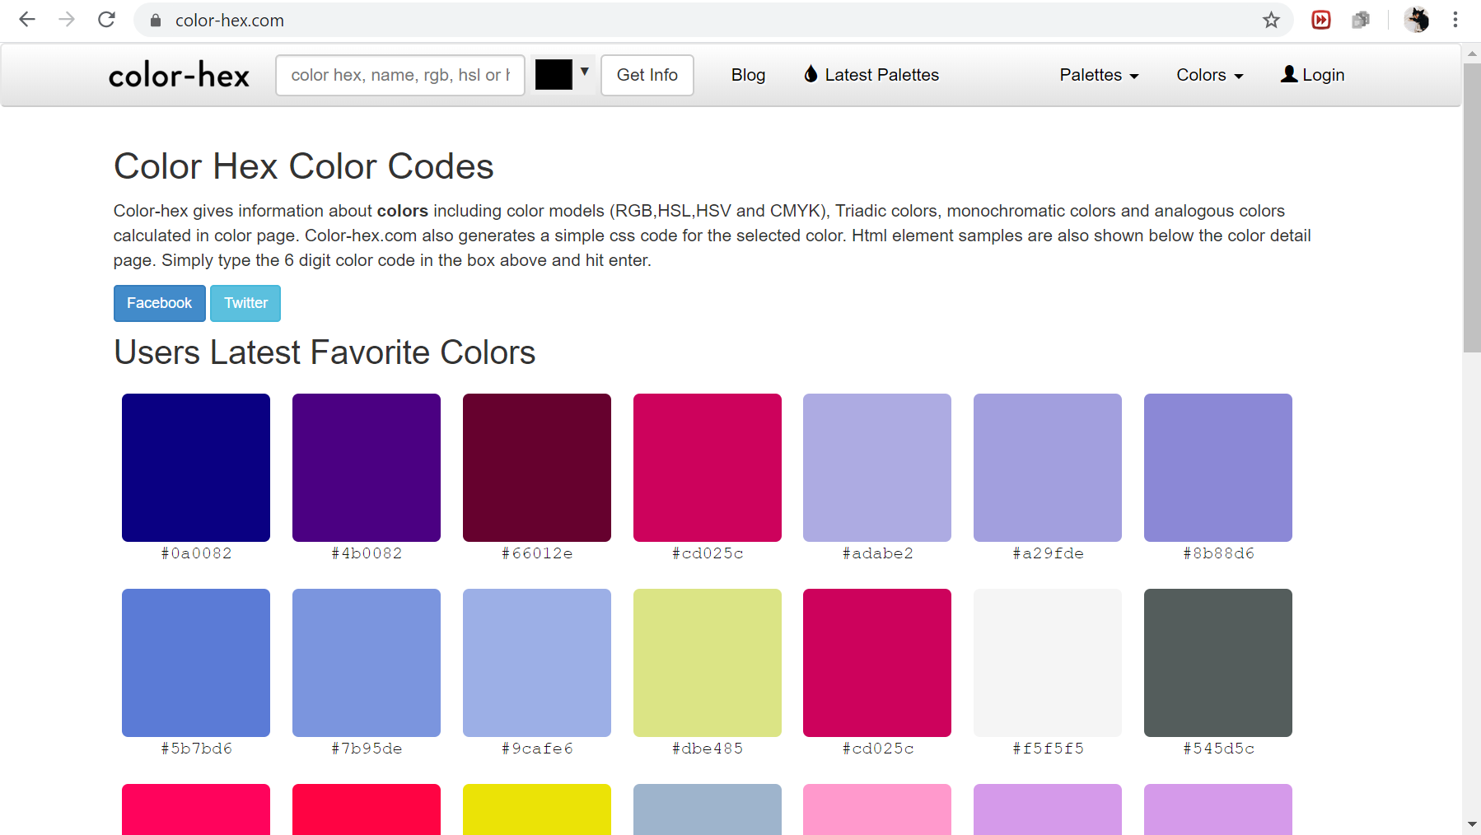Figure 10: Color-hex' Search Palette Webpage

1. Adobe Color CC Explore, <https://color.adobe.com/de/explore>

Description: The searchbar prompts the user to enter a keyword based on colors, atmospheres or concrete names such as ocean, wine, moonlight, happy or water. If a search for “sunflower” is carried out, most of the images have sunflowers in them or a sunflower text line. Thus, the keywords do not correspond to the search result’s color schemes, but rather to the objects in the images. First the images are searched in the Adobe Stock of images, then the images’ color schemes are rendered in a succeeding step. The camera icon in the searchbar makes it possible to upload an image on click and search similar images that have most of the same color patterns in common. The images in the search result all have their own color scheme of five color patches displayed at the bottom of the image. Sometimes the color scheme is returned without an image. When clicking on a color scheme, the HEX codes are shown for each color in the color scheme. Functionalities such as downloading or including the color schemes to a library requires an Adobe Creative Suite account.

Evaluation: It confuses the user to see these different keyword prompts in the searchbar, because this series of prompted words do not follow a logical sequence. The user cannot infer from the prompts which keywords are searchable and which are not. But, usually such a distinction is the purpose of making keyword prompts in the searchbar. In addition, returning both images with color schemes and color schemes in the search result seems to be too eclectic. On hovering over the image, the color scheme overrides the whole image. This, too, adds too much dynamism to the webpage.

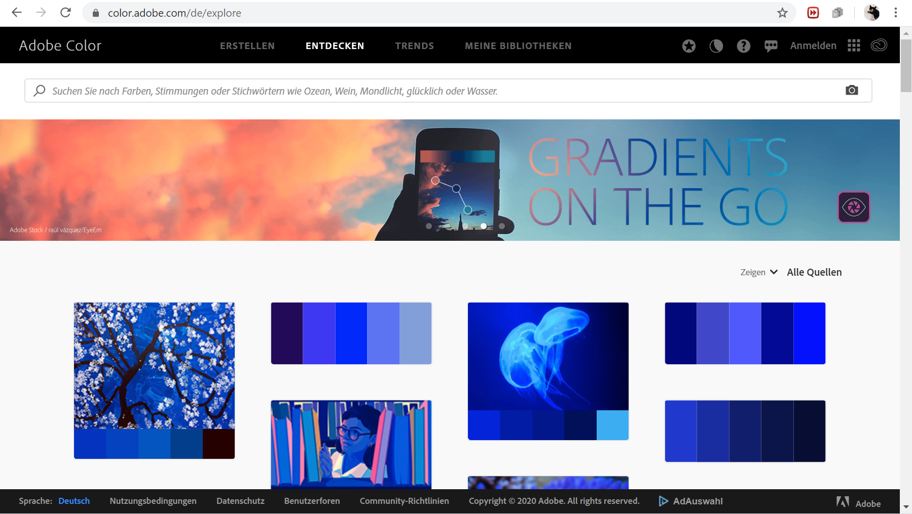Figure 11: Adobe Color CC Explore's Search Palette WEbpage

1. Colr, <http://www.colr.org/>

Description: The searchbar takes words as keywords and matches them to the tags attached to each color scheme. The user can create their own color scheme. The number of color patches in a color scheme is user-defined as well as the tags assigned to the color scheme. If there is only one color patch, it is called color and it is returned in the search result on the left. If there are more than one color patches, it is called a color scheme and these are returned in the search result on the right. The color scheme can be edited, expanded, similar schemes can be searched and as well as matching images. The color scheme is downloadable as .aco file and there is tag history for each color scheme. The colors of a color scheme are chosen using either a HEX code or a color picker. Matching paints and their color names are given in a separate window.

Evaluation: Tagging color schemes involves a lot of time and effort. Since tags are user-defined, any user can assign tags to colors and color schemes. If the matching is not done over a predefined list of color names and their corresponding colors, color name definitions will fluctuate over time and can be arbitrary at worst.

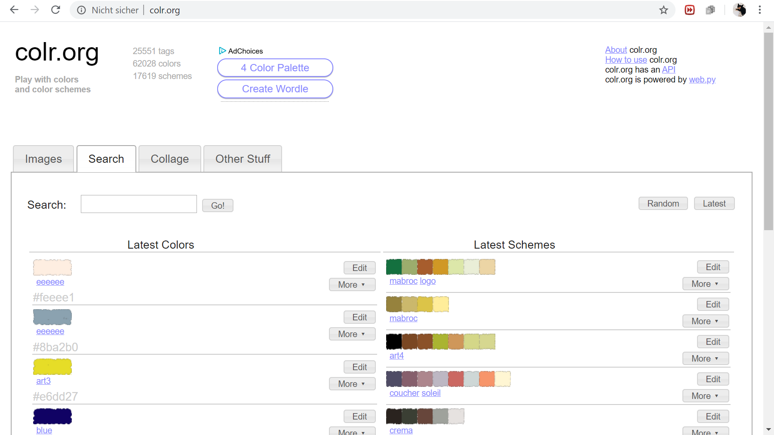Figure 12: Colr's Search Palette Webpage

1. Color Combos, <https://www.colorcombos.com/color-tags.html>

Description: This search bar prompts the user to enter a color name or hex code to find related color schemes of varying color patches called “color combo”. There is a list of all color names possible in the “popular color tags” section. The search result includes all color schemes, their names “ColorCombo” + a digit, the number of views, the number of comments and the number of likes. The color name is matched to different hex code colors. Each unique hex code color is assigned multiple tags. For example, color code #097054 is assigned the tags 097054, “blue green” and “watercourse”. The word tags can be assigned to a different color code as well. The tag description are defined by the administrator of the website. When clicking on a color scheme, the HEX, RGB, CMYK and HSV color codes are displayed together with the color image and the tags. There are functionalities for testing (editing) and copying the color scheme.

Evaluation: The tooltip could be improved to display only the hex code color of the selected color in the color scheme instead of listing the hex codes all at once. The color schemes rely on hex odes mostly. It is not possible to choose from the menu all possible color names in one go.

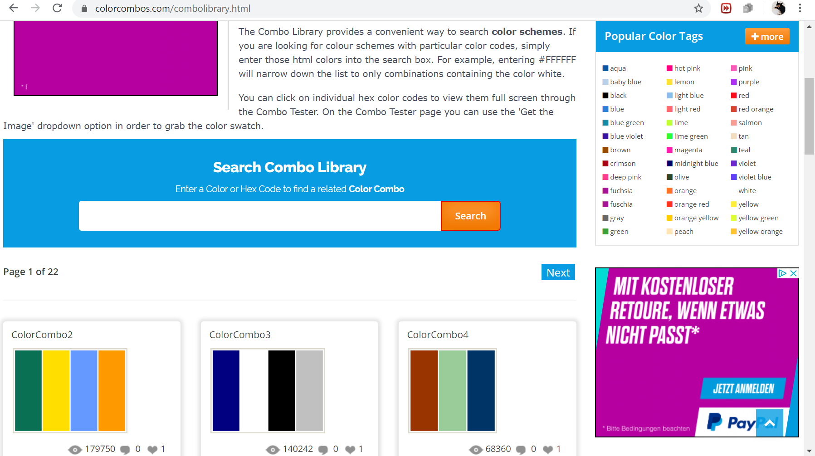Figure 13: Color Combo's Search Palette Webpage

1. Colorion, <https://www.colorion.co/search>

Description: Related Palettes can be searche for a given color. The colors can be chosen from a drop-down menu in the searchbar. The color names are lister under color categories such as pink, purple, red, orange, yellow, green, cyan, blue, brown, white and grey. For example, for pink six discrete color names together with the color image are displayed. The search result contains color schemes of varying length. Below the color schemes different buttons exist for sharing, saving, liking, obtaining more information and downloading the color scheme. When hovering over a color in a color scheme its hex code displays and by clicking the hex code is copied to the clipboard. In the information section, the hex code, the related color, the related hex code and the related color name is given for each color. The relation binds all similar hex code colors to a single color name category. There is color representative for all similar hex codes colors with the same color name. In addition, the RGB and HSL values are listed with type (dark/light), and the colors obtained from darkening or lightening the original color. Finally, the original color’s complementary color is shown. While the hex code has an exact match, the color names are matched to many different hex codes.

Evaluation: The color schemes are not named. The color patches look like location icons. The RGB and HSL values are formatted in a way that is not easily transferrable.

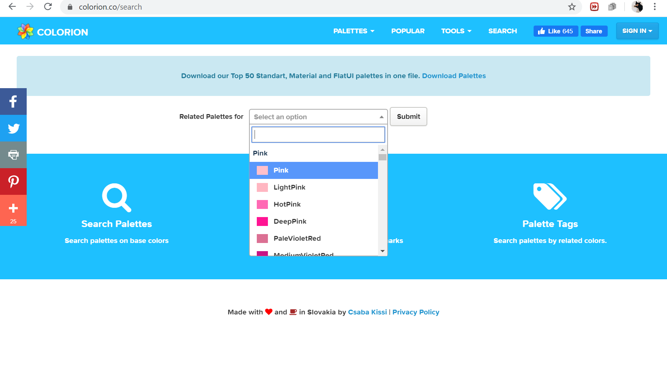Figure 14: Colorion's Search Palette Webpage

1. The list of all searchable color names are: blush, pink, red, currant, sand, peach, orange, umber, bone, butter, yellow, sage, seed, citrus, leaf, frond, sea-glass, enamel, turq, forest, ice, sky, sea, steel-blue, cloud, chambray, blue-sea, peacock, frost, periwinkle, blue, navy, petal, spring, violet, ore, cocoa, chipmunk, brown, deep-sepia, metal, aluminium, charcoal and black.